**6.1 NATURAL JOIN AND CROSS JOIN**

**CREATE TABLE EMPLOYEES(EMP_ID INT,EMP_NAME VARCHAR(20),DEP_ID INT PRIMARY KEY);**

**INSERT INTO EMPLOYEES VALUES (1,'Peter',100);**

**INSERT INTO EMPLOYEES VALUES (2,'Parker',101);**

**INSERT INTO EMPLOYEES VALUES (3,'Tony',102);**

**INSERT INTO EMPLOYEES VALUES (4,'Stark',103);**

**SELECT *FROM EMPLOYEES ORDER BY EMP_ID;**

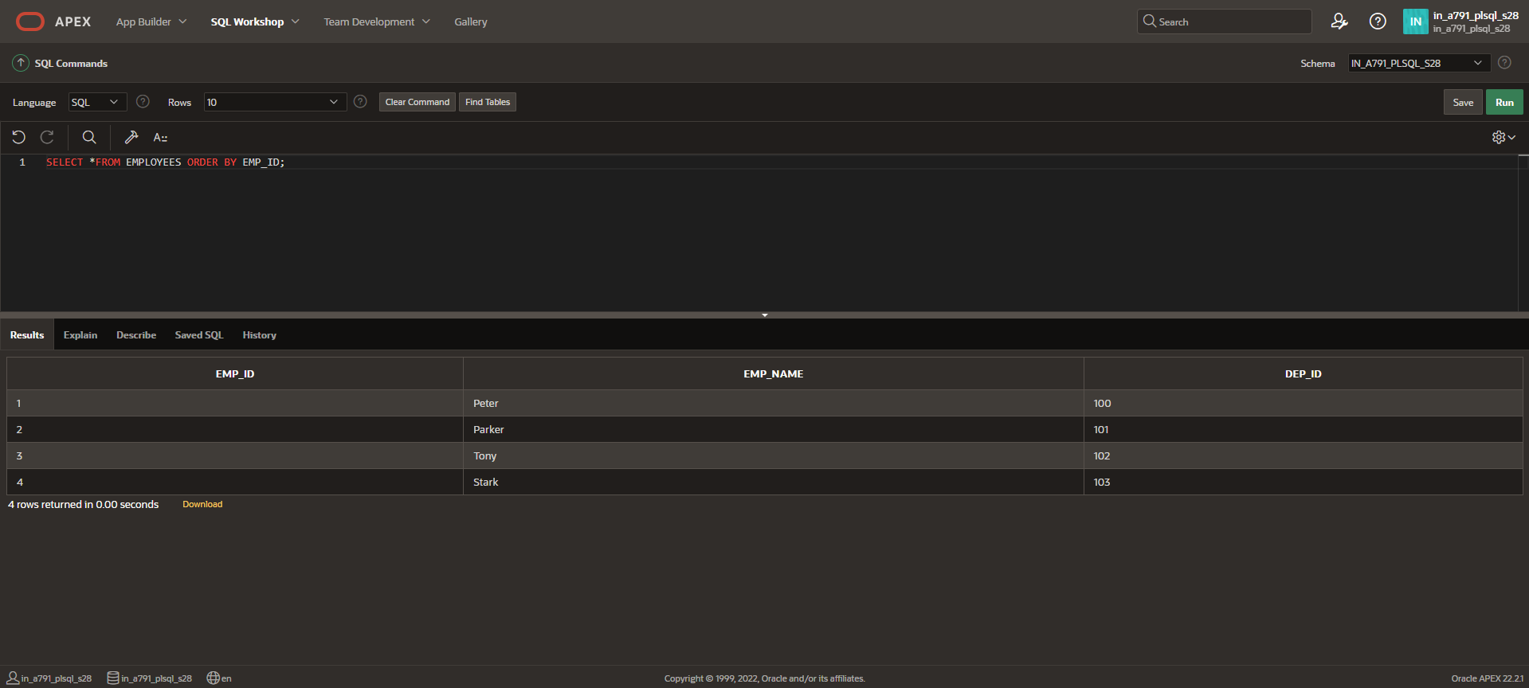

**CREATE TABLE DEP1 (DEP_ID INT PRIMARY KEY,DEP_NAME VARCHAR(20),FOREIGN KEY (DEP_ID) REFERENCES EMPLOYEES(DEP_ID));**

**INSERT INTO DEP1 VALUES (100,'IT');**

**INSERT INTO DEP1 VALUES (101,'CSE');**

**INSERT INTO DEP1 VALUES (102,'AIML');**

**INSERT INTO DEP1 VALUES (103,'AI&DS');**

**SELECT *FROM DEP1 ORDER BY DEP_ID;**

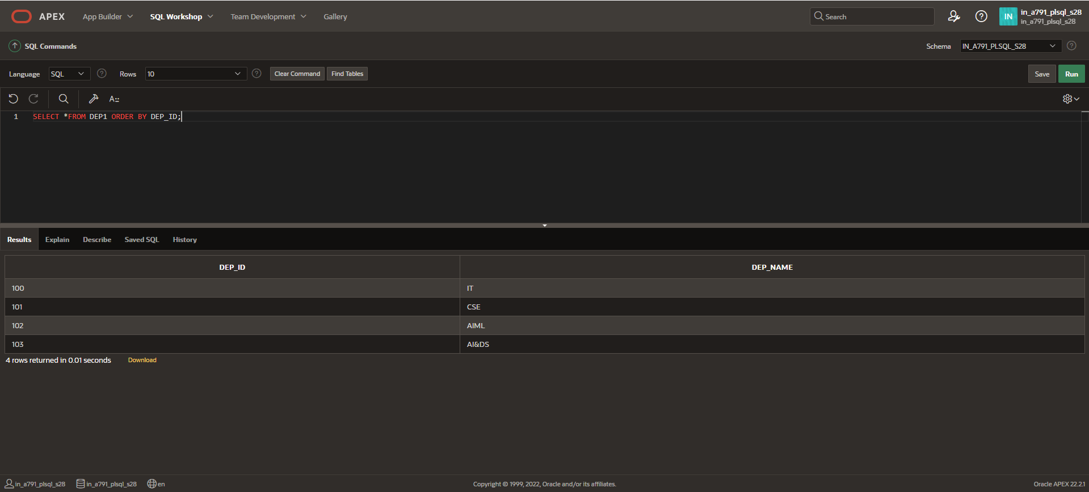

**NATURAL JOIN**

**SELECT EMP_ID,EMP_NAME FROM EMPLOYEES NATURAL JOIN DEP1;**

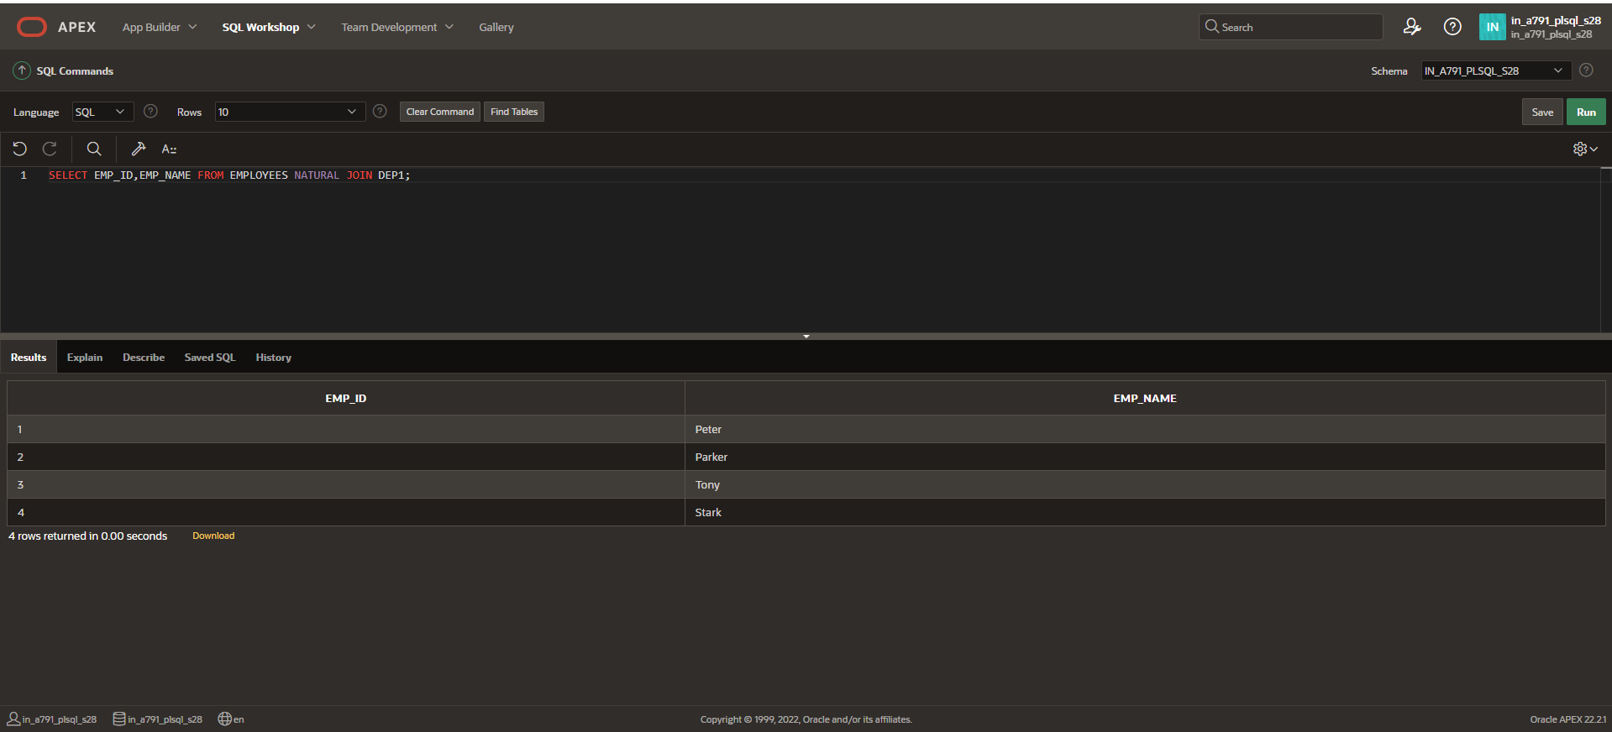

**CROSS JOIN**

**SELECT EMPLOYEES.EMP_NAME, EMPLOYEES.DEP_ID AS EMP_DEP_ID, DEP1.DEP_ID**

**FROM EMPLOYEES**

**CROSS JOIN DEP1;**

